Jmeter Performance Testing

Winter 2016 – Author: Thao Le

Contents

1. Week 1: Jmeter Fundamentals, Install and Create A Basic Jmeter Test Plan 4

2. Contact Us 8

# 

# Week 1: Jmeter Fundamentals, Install and Create A Basic Jmeter Test Plan

* Load, Stress And Performance Test
  + Load test: is the testing how the system works by increasing the load sending to the system. With load testing, we will know how many user using software product that the system still works properly.
  + Performance test: is the testing how software application performed such as how long it takes for the servers to response. With performance testing, we will know how long it takes for a software product get response so that we can improve the quality of software by making sure it will be run in the expected time response.
  + Stress test: is the testing how the system works under stress. With stress test, we will know at which point the system will be failed and how the system recovers back.
* What Is Jmeter?
  + Jmeter is a free application testing software from The Apache Software Foundation. Jmeter is a tool for running Load test, Performance test or Stress test. It is designed for testing Web Application, Web services (Soap & Rest api) and more.
* How does Jmeter work?
  + Jmeter acts like a group of users sending requests to a target server. It collects response from target server and other information which show the performance of the application via graphs or summary tables.
* Why Use Jmeter?
  + Jmeter is an open-source application. Therefore, it is very popular Test tool.
  + Jmeter has been created for 15 years and has a large community supporting.
  + Jmeter is one of the top Software Testing Tool for automation. Most of the opening job for software tester, QA engineer, Automation analyst, QA Analyst require or “good to have” Jmeter skill.
* Install Jmeter
* Below is Operating Systems can be run Jmeter. Even if your OS is not listed, Jmeter should run on it provided that the JVM is compliant.

|  |  |  |
| --- | --- | --- |
| **Operating system** | **JVMs** | **Arch** |
| Windows 8.1 | Oracle JDK 7 | 64 bits |
| Windows 7 | Oracle JDK 7 | 64 bits |
| Mac OSX 10.9.X | JDK 6 | 64 bits |
| Mac OSX 10.9.X | JDK 7u71 / 8u20 & 8u25 | 64 bits |

* + download Java:
* latest java version: https://www.java.com/en/download/windows-64bit.jsp
* Following the Instruction from Java to install. Then set up JAVA_HOME environment variable by these steps
* Open Control Panel\System and Security\System on your computer

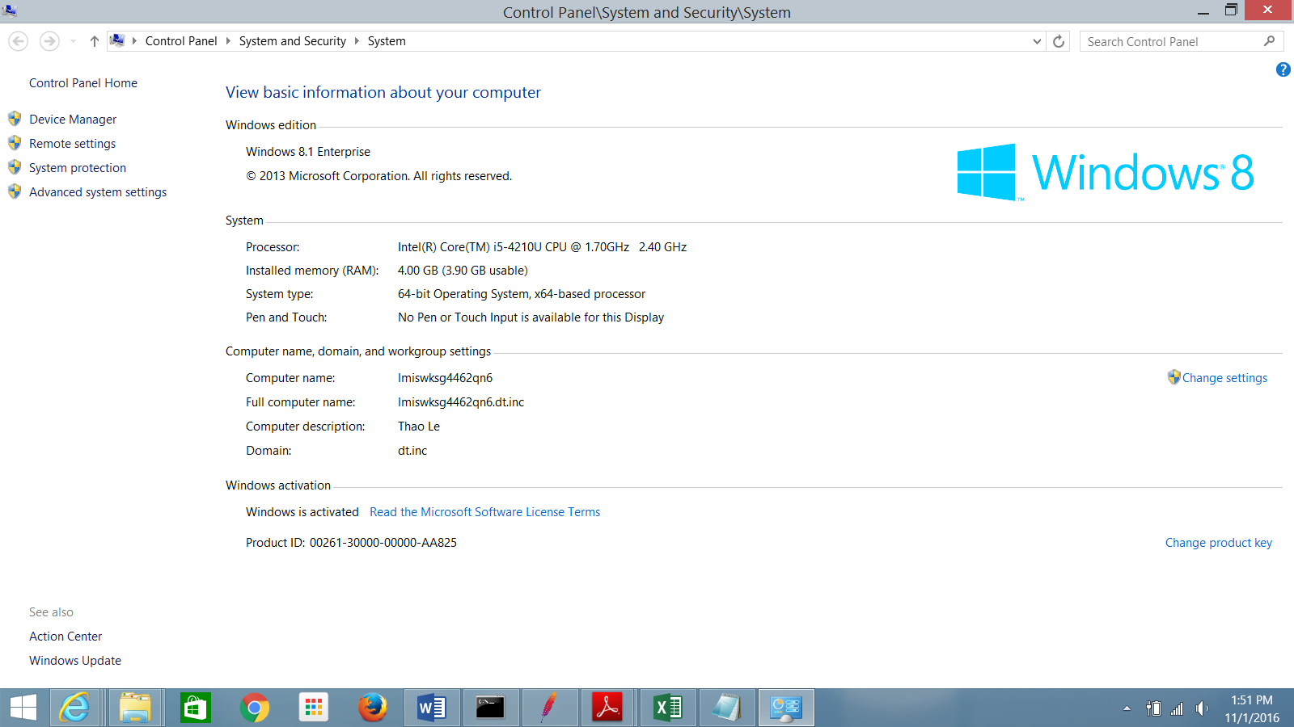

* Choose Advance system setting

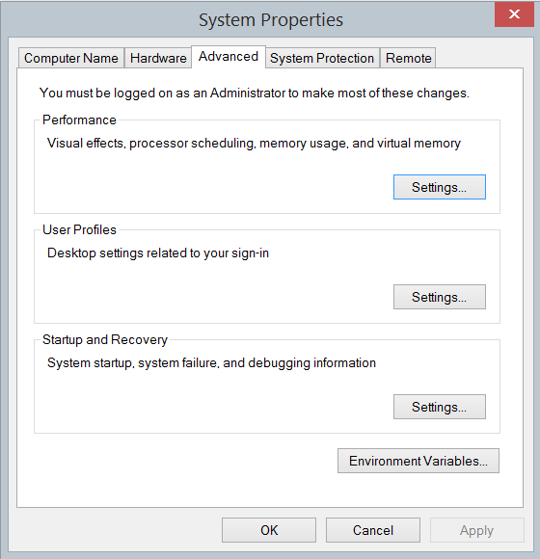

* Click on Environment Variables

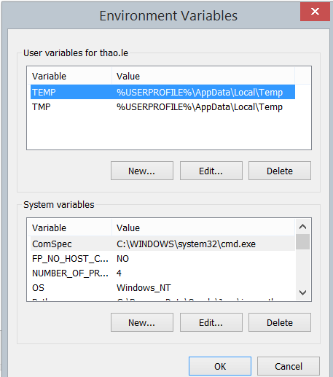

* Select Path under System variables and click on Edit

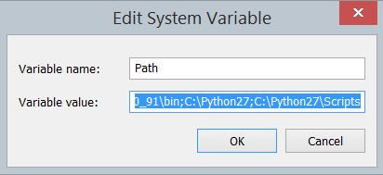

* At the end of Variable value, put path where is Java\Bin folder such as C:\Program Files (x86)\Java\jre1.8.0_91\bin
* Then click on OK. Make sure you don’t remove any existing Variable value.
  + download Jmeter: [http://Jmeter.apache.org/download_Jmeter.cgi](http://jmeter.apache.org/download_jmeter.cgi) . To install Jmeter, simply unzip the zip/tar file into the directory where you want Jmeter to be installed (zip file is for Window, tar file is for Unix). Make sure that you have a JRE/JDK correctly installed and the JAVA_HOME environment variable set.
  + To run Jmeter: run the Jmeter.bat (for Windows) or Jmeter (for Unix) file. These files are found in the bin directory.
* Jmeter Test Plan: Basic Elements (Thread Group, Sampler, Assertion, Listener)
  + Thread group: is to set up number of user to run the test
  + Sampler: is the request for running the test (http/https/soap/rest)
  + Assertions: are to use for comparing the actual result with the expected result so that we can decide if the test is passed
  + Listeners: are the reports from Jmeter